**CEDS Genotyping Documentation**

**Table 1.** *Available Child Genotypes and HWE (White Ethnicity N=264)*

|  |  |  |  |  |  |
| --- | --- | --- | --- | --- | --- |
| **Gene** | **SNP** | **System** | **HWE p-value** | **MAF** | **N** |
| Adrenergic beta 1 | rs1801253 | ANS | .27 | .08 | 254 |
| Adrenergic beta 2A | rs1042714 | ANS | .78 | .23 | 256 |
| Beta adrenergic receptor kinase (ADRBK1) | rs17098707 | ANS | **.00\*** | - | 259 |
| VMAT1 (SLCF18m1) | rs1390938 | ANS | .43 | .05 | 260 |
| Dopamine beta hydroxylase (DBH) | rs1611115 | ANS | .14 | .04 | 223 |
| Muscarinic Receptor (CHRM2) | rs324650 | ANS | .89 | .23 | 256 |
| GR | rs41423247 | HPA | .20 | .15 | 255 |
| rs6195 | HPA | .09 | - | 257 |
| MR | rs5522 | HPA | .11 | .02 | 253 |
| rs2070951 | HPA | **.01\*** | .29 | 243 |
| FKBP5 | rs4713916 | HPA | .54 | .10 | 240 |
| rs9470080 | HPA | .53 | .10 | 256 |
| rs1360780 | HPA | .41 | .09 | 257 |
| Serotonin Receptor 1B | rs6296 | HPA | .62 | .07 | 256 |
| Serotonin Receptor 2A | rs6311 | HPA | .89 | .19 | 255 |
| rs6313 | HPA | .77 | - | 247 |
| rs6314 | HPA | .86 | .01 | 257 |
| CRHR1 | rs110402 | HPA | .48 | .23 | 254 |
| AVBP 1B | rs35369693 | HPA | .89 | - | 257 |
| rs28632197 | HPA | .48 | .01 | 243 |
| GABAA R | rs3219151 | HPA | .41 | .17 | 256 |
| rs11503014 | HPA | .82 | .09 | 256 |
| COMT | rs4680 | HPA | **.01\*** | .20 | 259 |
| BDNF | rs6265 | HPA | **.00\*** | .04 | 231 |
| Oxytocin Receptor | rs2254298 | HPA | .82 | .01 | 263 |
| Estrogen Receptor (ESR1) | rs9304799 | Other | .08 | .17 | 259 |
| rs2234693 | Other | .12 | .02 | 136 |

***Gene and Variant Selection***

Genes were selected for this study primarily using a pathways approach. Protein interaction network and pathway-based analysis represent an alternative approach to candidate gene selection (Sun et al, 2010), which may prove to be effective in the investigation of molecular mechanisms underlying psychopathology. Investigation of genetic variants often focuses on the selection of a limited number of (single nucleotide polymorphism) SNPs in selected genes or alternatively hypothesis-free genome-wide methods. A method which avoids some of the associated disadvantages of these methods is the pathway approach, which investigates variability within a pathway, rather than restricting analysis to a single gene (Kooloos et al, 2009) or set of unrelated genes.

**HPA - Cortisol**

Genes were selected primarily using a pathways approach. We selected candidate genes involved in HPA axis function. Specifically, we used the ingenuity pathways database (www.ingenuity.com) with the search terms ‘glucocorticoid receptor signalling’ and ‘corticotropin releasing hormone’ and the literature database Pubmed ([www.ncbi.nlm.nih.gov/pubmed](http://www.ncbi.nlm.nih.gov/pubmed)) to identify genes involved in HPA axis function. Pathways were inspected and relevant genes selected, see Table 2 for a list of the genes selected. SNPs within the pathway genes were then selected based on literature searches, functional information obtained from the National Centre for Biotechnology Information database dbSNP, minor allele frequencies (>0.1) and based on linkage disequilibrium (LD) plot information using the tagging program Haploview.

**Table 2. Sequenom *Genotyping Panel 1 (Child Genotypes)***

|  |  |  |  |  |
| --- | --- | --- | --- | --- |
| **Gene** | **SNPs Selected** | **rs numbers** | **Compatible for Panel** | **Data Generated** |
| GR | *bcl*I | rs41423247 | Yes | Yes |
| N363S | rs6195 | Yes | Yes |
| A3669G | rs6198 | Yes | - |
| MR | I180V | rs5522 | Yes | Yes |
| -2G/C | rs2070951 | Yes | Yes |
| FKBP5 | T31378C | rs4713916 | Yes | Yes |
| A93790G | rs1360780 | Yes | Yes |
| A54926G | rs9470080 | Yes | Yes |
| CRHR1 | 9154199  A/C/G/T | rs110402 | Yes | Yes |
| Serotonin Receptor 1B | Val287Val | rs6296 | Yes | Yes |
| Serotonin Receptor 2A | A(-1438)G | rs6311 | - | See panel 2 |
| His452Tyr | rs6314 | - | See panel 2 |
| T(102)C | rs6313 | - | See panel 2 |
| G28110A | rs6561336 | Yes | - |
| A68740C | rs9595552 | Yes | - |
| AVBP1B | Lys65Asn | rs35369693 | Yes | Yes |
| Arg364His | rs28632197 | Yes | Yes |
| A150849G | rs28373064 | Yes | - |
| C1442G | rs33976516 | - | - |
| G158557A | rs33933482 | Yes | - |
| T8742483C | rs237889 | Yes | - |
| GABA A Receptor | T1521C | rs3219151 | Yes | Yes |
| G6192C | rs11503014 | Yes | Yes |
| ESR1 | T156705C | rs2234693 | Yes | Yes |
| A>T | rs9304799 | Yes | Yes |
| GSTP1 | Ala114Val | rs1138272 | Yes | - |
| G7188A | rs749174 | Yes | - |

**ANS – Heart Rate**

The major neurotransmitter system governing heart rate is the noradrenergic system. We therefore primarily selected candidate genes related to both the biosynthesis of noradrenaline as well as downstream adrenergic signalling. Specifically, we used the reactome database (www.reactome.org) with the search terms ‘noradrenaline biosynthesis’ and ‘noradrenaline binding’ to identify genes involved in noradrenaline biosynthesis and adrenergic receptor signalling, respectively. Relevant pathways returned from the database were ‘catecholamine biosynthesis’ and ‘adrenoceptors’. These pathways were visually inspected and relevant genes selected, see Table 3 for a list of the genes selected. We selected genes to represent both arms of the noradrenergic response including the key biosynthetic enzymes tyrosine hydroxylase (TH), dopa decarboxylase (DDC) and dopamine beta hydroxylase, as well as the receptors that direct the excitatory activity of noradrenaline, the adrenergic receptors beta 1, beta 2 and alpha 2 (see Figure 1). Furthermore, we also selected the CHRM2 gene which is involved in inhibitory signalling which serves to reduce heart rate. HPA axis genes that failed panel 1 were also included on panel 2.

Variants within the candidate genes were selected based on their potential to functionally disrupt the system, using information obtained from the National Centre for Biotechnology Information database dbSNP and minor allele frequencies (>0.1).

**Table 3. Sequenom genotyping Panel 2 (Child Genotypes)**

|  |  |  |  |  |
| --- | --- | --- | --- | --- |
| **Gene** | **SNPs Selected** | **rs numbers** | **Compatible for Panel** | **Data Generated** |
| Adrenergic Receptor Beta 1 (*ADRB1*) | Arg389Gly | rs1801253 | Yes | Yes |
| Ser49Gly | rs1801252 |  | - |
| Adrenergic Receptor Beta 2 (*ADRB2*) | Gln27Glu | rs1042714 | Yes | Yes |
| Arg16Gly | rs1042713 |  | - |
| Adrenergic Receptor Alpha 2 (*ADRA2A*) | C1291G | rs1800544 | Yes | - |
| Adrenergic Receptor Beta Kinase 1 (*ADRBK1/GRK5*) | Gln41Leu | rs17098707 | Yes | Yes |
| Noradrenaline Transporter (*NET/SLC6A2*) | Ala31Pro | rs13306039 | Yes | - |
| G1432A | rs1805067 |  | - |
| Phenylethanolamine N-Methyltransferace (*PNMT*) | Ser188Cys | rs5639 | Yes | - |
| Leu211His | rs5640 |  | - |
| Vesicular Monoamine Transporter 1 (*VMAT1/SLC18A1*) | Ile136Thr | rs1390938 | Yes | Yes |
| Dopamine Beta Hydroxylase (*DBH*) | C1021T | rs1611115 | Yes | Yes |
| Arg549Cys | rs6271 | - | - |
| Tyrosine Hydroxylase (*TH*) | Val108Met | rs6356 | Yes | - |
| Dopa Decarboxylase (*DDC*) | A14870G | rs921451 | Yes | - |
| Muscarinic Receptor 2 (*CHRM2/M2*) | T145263A | rs324650 | Yes | Yes |
| Serotonin Receptor 2A | G1438A | rs6311 | Yes | Yes |
| T102C | rs6313 | Yes | Yes |
| His452Tyr | rs6314 | Yes | Yes |
| BDNF | Val66Met | rs6265 | Yes | Yes |
| COMT | Val158Met | rs4680 | Yes | Yes |
| Oxytocin receptor | G>A | rs2254298 | Yes | Yes |
| ESR1 | T>A | rs9304799 | Yes | Yes |

**Figure 1. Adrenergic Biosynthesis and Signalling**

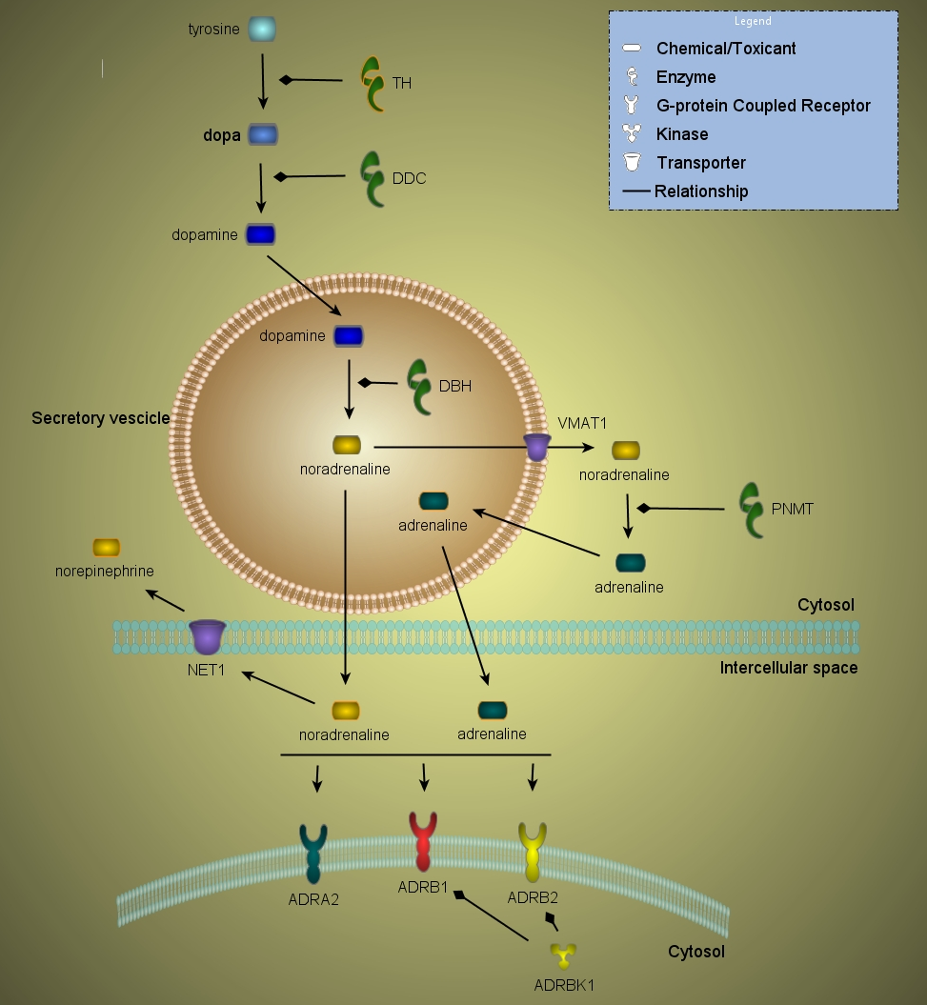

**Methods**

***Sequenom Genotyping***

DNA was extracted from buccal swabs as described by Freeman et al. (2003). Polymerase-chain-reaction (PCR) assays and extension primers were designed with the use of MassARRAY software (Sequenom), using ~20ng of DNA for amplification. A panel of SNPs was genotyped on the SEQUENOM® iPLEX® platform according to the manufacturer’s instructions. Nine PCR-negative controls were included in the 384-well plate.

Multiplex genotyping is a time and cost effective method for genotyping multiple SNPs simultaneously. However, this method does have limitations in that not all SNPs are compatible on one platform due to the compatibility of primers. Furthermore, usable data were not generated for some of the SNPs that were included on the platform. There was no minor allele frequency information for some of the 11 SNPs included on the panel, genotyping of these SNPs generated homozygous data for one allele in all cases. We were therefore unable to use this data. Genotyping of other SNPs resulted in homozygous data for one allele in almost all cases and was therefore unusable; this may reflect the failure of these assays to amplify due to the multiplex strategy.

***VNTR Genotyping***

DNA was extracted from buccal swabs as described by Freeman et al. (2003). VNTR polymorphisms were genotyped using standard PCR protocols using a PTC-225 thermocycler. Reagent concentrations, primer sequences and cycling condition can be found in Tables 4-6. PCR fragments were resolved on a 2% Ethidium Bromide stained agarose gel by electrophoresis for 1.5 hours at 220 Volts. Visualisation under UV allowed for identification of genotypes.

**Table 4.** Reagents used for in-house genotyping of VNTR markers.

|  |  |  |  |  |  |  |  |  |
| --- | --- | --- | --- | --- | --- | --- | --- | --- |
|  | Reagent | | | | | | | |
| *Marker* | *DMSO* |  | *MgCl2* | *NH4 Buffer* | *Primer For. (pmol)* | *Primer Rev. (pmol)* | *Taq Polymerase (units)* | *H2O* |
| DRD4 Exon 3 | 10% |  | 25mM | 10X | 5 | 5 | 1 | up to 10ul |
| 5-HTTLPR | - |  | 25mM | 10X | 5 | 5 | 1 | up to 10ul |
| MAOA Promoter | - |  | 25mM | 10X | 5 | 5 | 1 | up to 10ul |

**Table 5.** Primers used for VNTR genotyping along with the possible genotypes for each marker.

|  |  |  |  |
| --- | --- | --- | --- |
| Marker | Forward Primer (5' → 3') | Reverse Primer (5' → 3') | Possible Genotypes |
| DRD4 Exon 3 | GGTCTGCGGTGGAGTCTG | GCGACTACTACGTGGTCTACT | 2, 3, 4, 5, 7 |
| 5-HTTLPR | TCGAGGCTGAGCGTCTAGAGGGACTGAGCT | CTTGTTGGGGATTCTCCCGCCTGGCGT | Long, short |
| MAOA Promoter | CAGCGCCCAGGCTGCTCCAGA | GGTTCGGGACCTGGGCAGTTGTGC | 3, 3.5, 4, 5 |

**Table 6.** PCR cycling conditions for VNTR genotyping.

|  |  |  |  |
| --- | --- | --- | --- |
|  | *PCR Cycle conditions* | | |
| *Marker* | *Temp (oC)* | *Time (mins)* | *cycles* |
| DRD4 Exon 3 | 94 | 7.5 | 1 |
|  | 94 | 0.4 | 4 |
|  | 56 | 0.4 |
|  | 72 | 0.4 |
|  | 94 | 0.4 | 4 |
|  | 55 | 0.4 |
|  | 72 | 0.4 |
|  | 94 | 0.4 | 27 |
|  | 54 | 0.4 |
|  | 72 | 0.4 |
|  | 72 | 5 | 1 |
| 5-HTTLPR | 95 | 10 | 1 |
|  | 95 | 1 | 30 |
|  | 65 | 1 |
|  | 72 | 1 |
|  | 72 | 10 | 1 |
| MAOA Promoter | 95 | 10 | 1 |
|  | 95 | 1 | 30 |
|  | 65 | 1 |
|  | 72 | 1 |
|  | 72 | 10 | 1 |